**EXPERIMENT 9**

**Aim:**

Multiple tone player using Buzzer controlled by Arduino UNO.

**Components Required:**

1. Buzzer
2. Resistors
3. Arduino UNO
4. Jump wires
5. USB cable

**Theory:**

The main element in a buzzer is a piezo (a Greek word meaning to squeeze), which oscillates and creates a tone when you apply DC power to it.

Piezo buzzers are very reliable and come in various form factors. You can see applications of piezo buzzers in toys, microwave ovens, washing machines, other appliances, etc.

The piezo buzzer has two pins. Positive (Red) and negative (black) wire.

Connect the negative wire to the GND pin and the positive wire to a PWM pin of the Arduino.

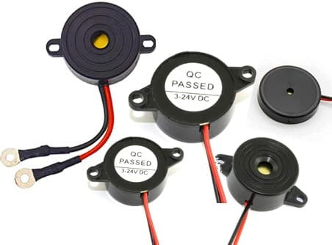 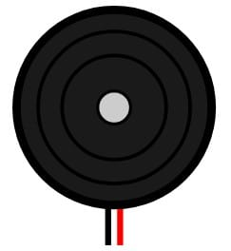

**Rated Voltage** – This is the voltage at which all other specifications (sound, current consumption, etc.) mentioned in the datasheet are measured.

**Operating Voltage range** – Safe operating voltage range, which you can use to work with the buzzer. For example, if you work with the Arduino UNO, the voltage applied to the buzzer will be 5 V. It is still acceptable if 5V is in the operating voltage range.

**Operating Temperature Range:** Temperature range beyond which the buzzer performance will not be reliable or permanently fail.

**Frequency**: Most Piezo buzzers have ratings from **2 to 4 kHz.** The frequency range will be in the audible range (20 Hz to 20 kHz).

**Sketch Code:**

int pos = 0;

void setup()

{

pinMode(8, OUTPUT);

pinMode(6, OUTPUT);

pinMode(7, OUTPUT);

}

void loop()

{

noTone(8);

tone(6, 880, 200); // play tone 69 (A5 = 880 Hz)

delay(200);

noTone(6);

tone(7, 988, 500); // play tone 71 (B5 = 988 Hz)

delay(500);

noTone(7);

tone(8, 1047, 300); // play tone 72 (B5 = 1047 Hz)

delay(300);

}

**Result:**

Upon completion of the experiment, the Buzzer should be successfully worked with the Arduino UNO . Various sounds should be produced by the buzzer.

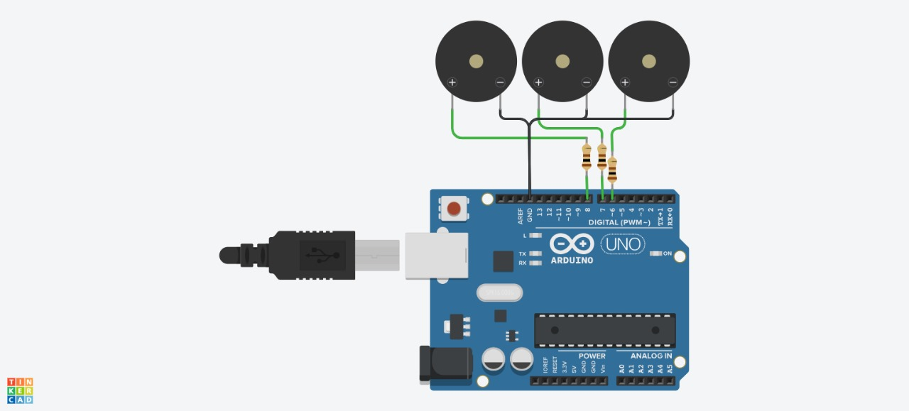

**Conclusion:**

In this experiment, we successfully interfaced a DC motor with an Arduino UNO. We learned how to control and make different types of sound using digital output pins of the Arduino UNO. This experiment serves as a fundamental building block for various robotics and automation projects requiring Buzzer.